Bible Talk Series
The Letter to the Hebrews

“Jesus is Better”

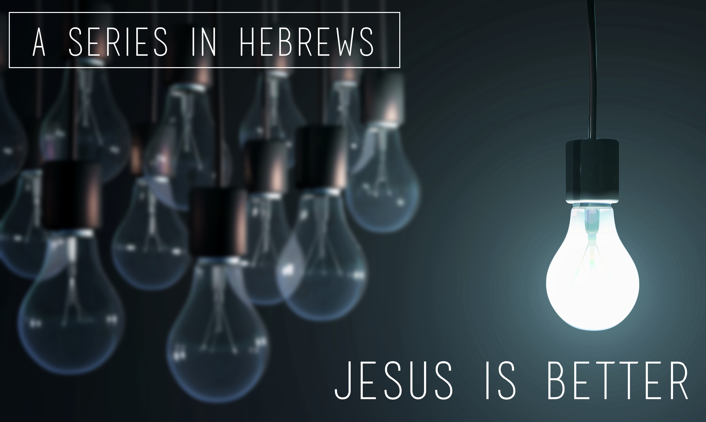

Glenn Lyons
Contact: glenn@reachsa.org.za
Website: https://presidingbishop.co.za/

Session 22
A Call to Community (II) Hebrews 13:7-25

- Imitate Christlike Leadership (v.7,8)

- Stand Steadfast in Grace (v.9,10)

- Endure Worldly Disgrace (v.11-14)

- Practice Sacrificial Worship (v.15,16)

- Submit to your leaders (v.17-25)

- Pray for your Leaders

- Pray for each other

“Now may the God of peace, who through the blood of the eternal covenant brought back from the dead our Lord Jesus, that great Shepherd of the sheep, equip you with everything good for doing his will, and may he work in us what is pleasing to him, through Jesus Christ, to whom be glory for ever and ever. Amen.” (Heb.13:20,21)

