Bible Talk Series
The Letter to the Hebrews

“Jesus is Better”

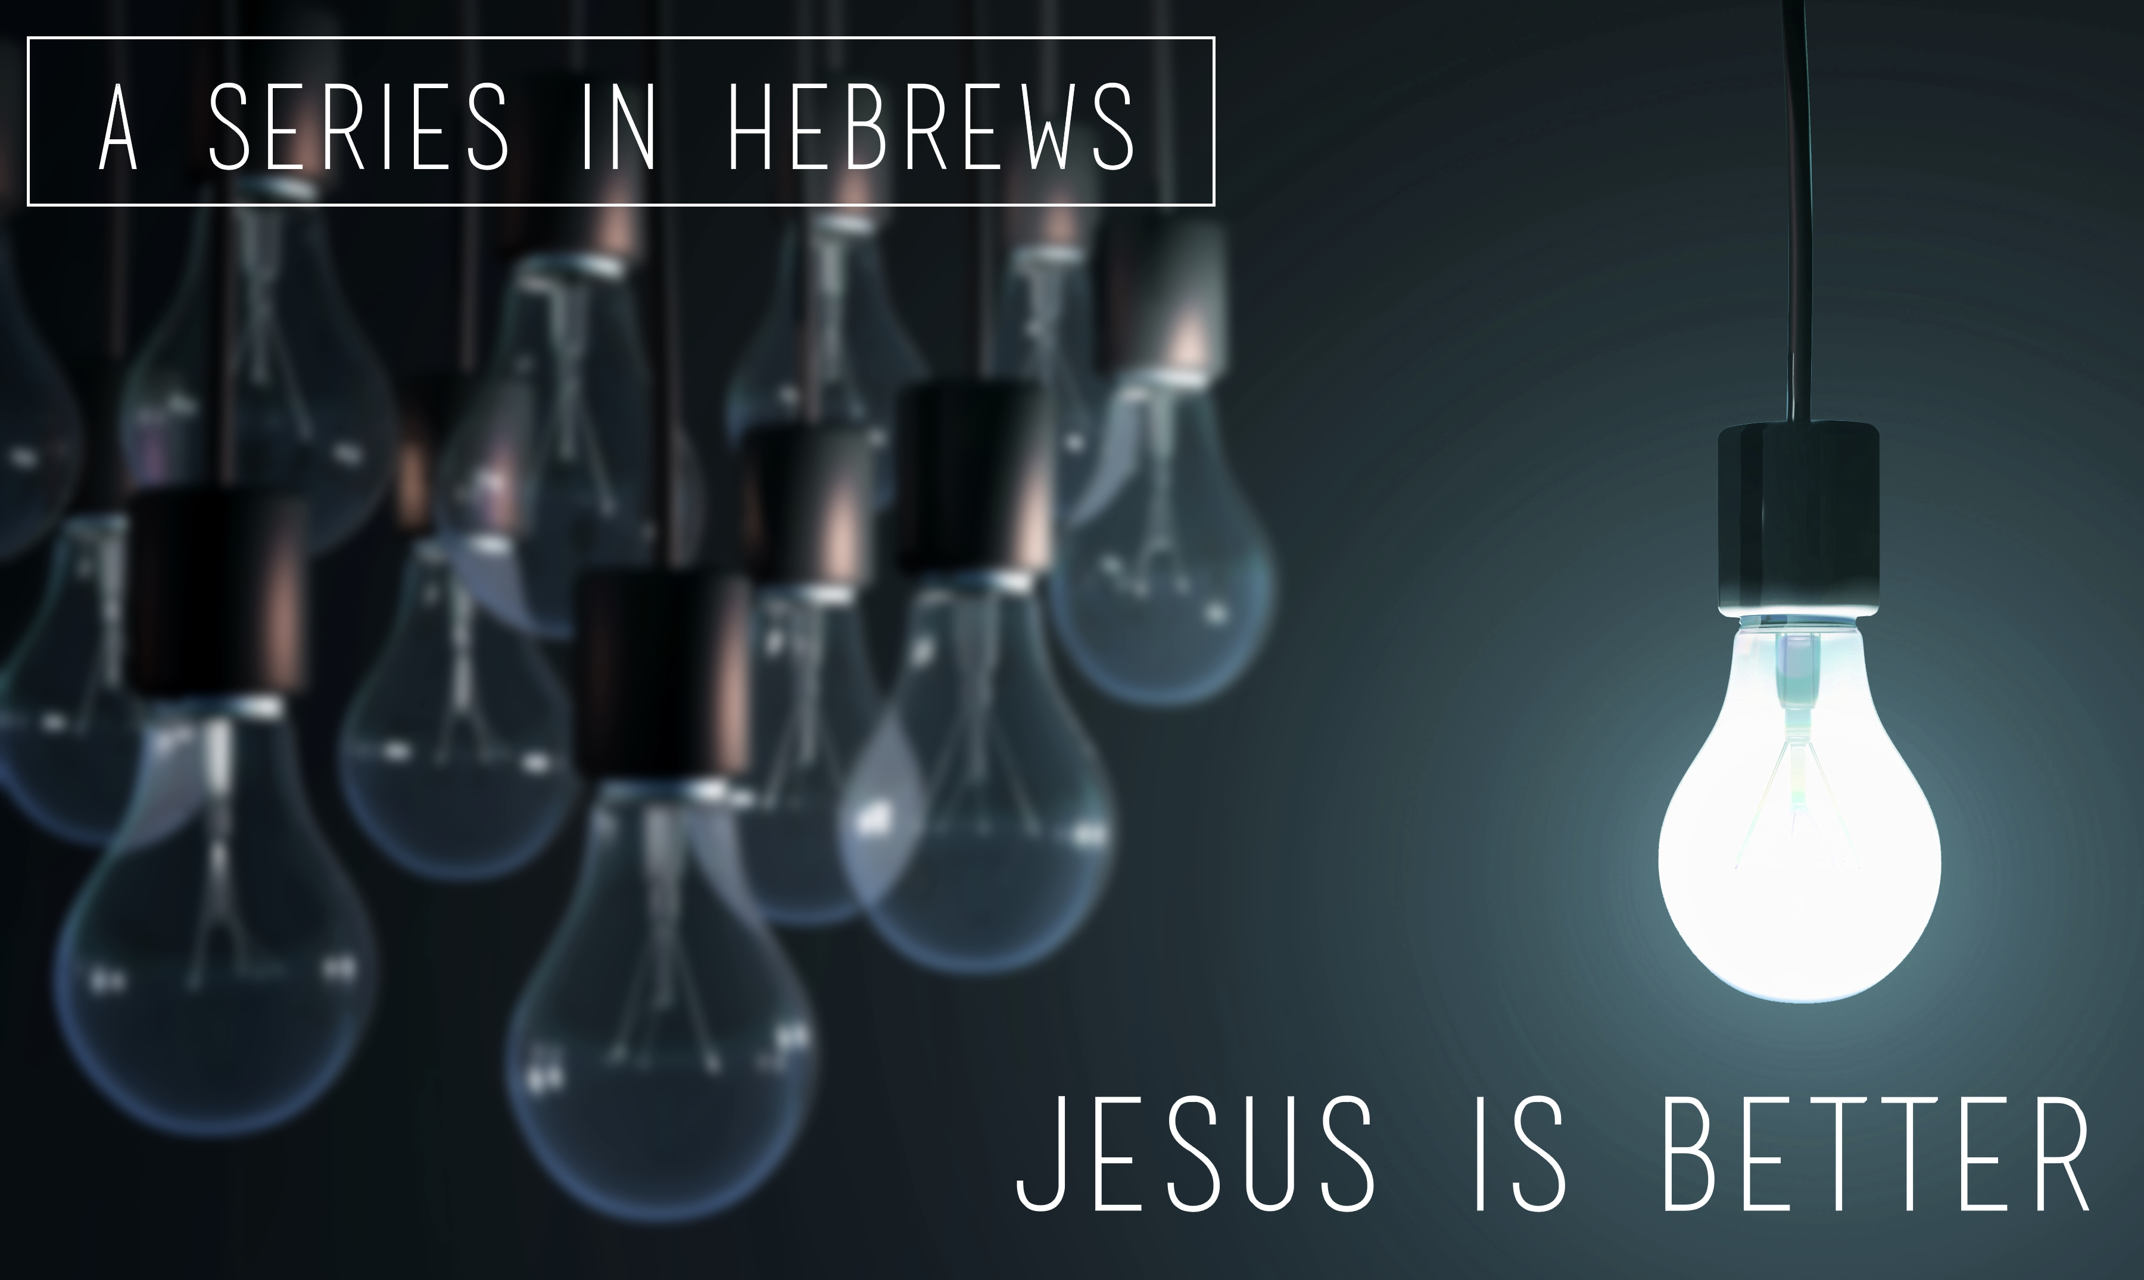

Glenn Lyons
Contact: glenn@reachsa.org.za
Website: https://presidingbishop.co.za/

Session 16
Faith to the Finish (I) (Hebrews 11:1-16)
Context: Heb.10:36-39

Now faith is the substance of things hoped for, the evidence of things not seen. (Heb.11:1 KJV)

- Commendable Faith (11:1-6)

- Authentic Faith (v.6-12)

- Noah (v.7)
- Abraham (v.8-12) (Genesis 12:1-4)

- Unfailing Faith (v.13-16)

“All these people were still living by faith when they died. They did not receive the things promised; they only saw them and welcomed them from a distance…” (Heb.11:13a)

