Bible Talk Series
The Letter to the Hebrews

“Jesus is Better”

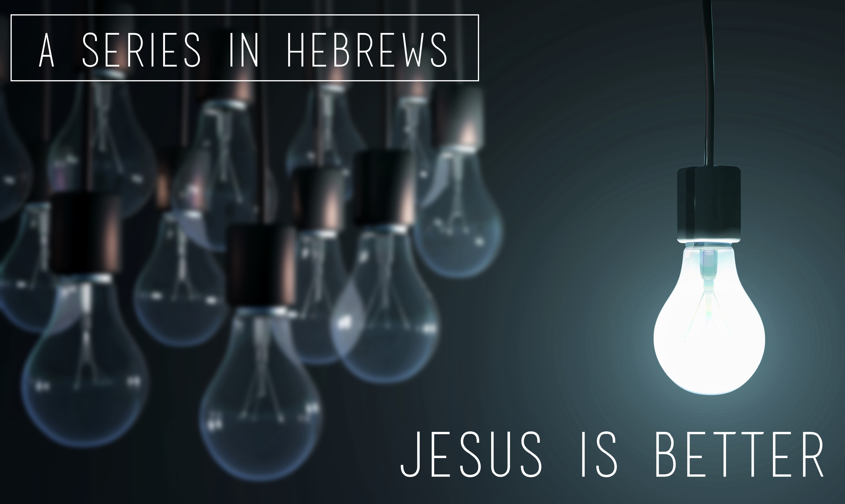

Glenn Lyons
Contact: glenn@reachsa.org.za
Website: https://presidingbishop.co.za/

Session 6
A Better Rest (Heb.4:1-13)

- The Future Promise of Rest (v.1-5)

- The Present Labour of Faith (v.6-11)

- The Test of Authenticity (v.12,13)
  - Present
  - Future

