Bible Talk Series
The Letter to the Hebrews

“Jesus is Better”

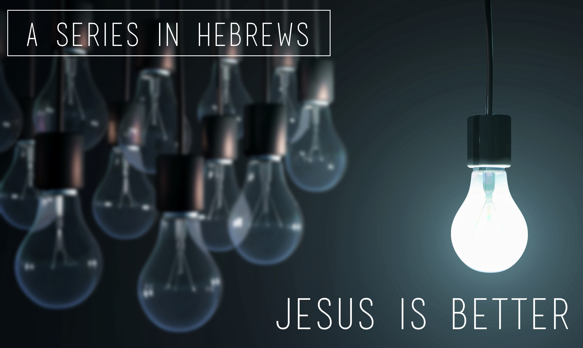

Glenn Lyons
Contact: glenn@reachsa.org.za
Website: https://presidingbishop.co.za/

Session 3
A Better Human (Hebrews 2:5-18)
- Humankind – Creation’s Crown (2:5-9)

Psalm 8
O Lord, our Lord, how majestic is your name in all the earth!
You have set your glory above the heavens.
² Out of the mouths of babes and infants,
you have ordained praise because of your foes,
to silence the enemy and the avenger.
³ When I look at your heavens, the work of your hands,
the moon and the stars, which you have set in place,
⁴ what is man that you are mindful of him,
the son of man, that you care for him?
⁵ Yet you have made him a little lower than the angels
and crowned him with glory and honour.
⁶ You have given him dominion over the works of your hands;
you have put all things under his feet,
⁷ all sheep and oxen, and also the beasts of the field,
⁸ the birds of the heavens, and the fish of the sea,
all that swim the paths of the seas.
⁹ O Lord, our Lord, how majestic is your name in all the earth!

- Corporate Failure (v.8)
“Yet at present we do not see everything subject to them (him)” (2:8b)

- Representative Victory (v.9)
⁹ But we do see Jesus, who was made lower than the angels for a little while, now crowned with glory and honour because he suffered death, so that by the grace of God he might taste death for everyone. (2:9)

- The Suffering, Saving Son (2:10-13)

- The Son, our Perfect Representative (2:14-18)
“For surely it is not angels he helps, but Abraham’s descendants.” (Heb.2:16)
“Understand, then, that those who have faith are children of Abraham” (Gal.3:7)

¹⁷ For this reason he had to be made like them, fully human in every way, in order that he might become a merciful and faithful high priest in service to God, and that he might make atonement for the sins of the people. ¹⁸ Because he himself suffered when he was tempted, he is able to help those who are being tempted. (Heb.2:17,18)

