Bible Talk Series
The Letter to the Hebrews

“Jesus is Better”

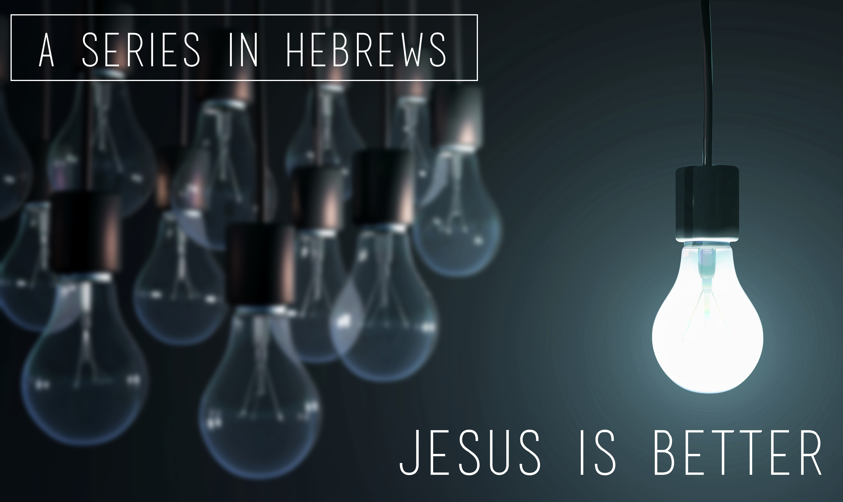

Glenn Lyons
Contact: glenn@reachsa.org.za
Website: https://presidingbishop.co.za/

Session 2
A Better Name (Hebrews 1:4-2:4)

- The Superior Son (1:4-14)

- Superior ………………………………… (v.4,5)

- Superior ………………………………… (v.6)

- Superior …………………………………….. (v.7-9)

- Superior ……………………………………… (v.10-12)

- Superior …………………………………………. (v.13,14)

- Pay attention to the Son (2:1-4)

- The Warning (2:1)

- The Consequences (2:2,3a)

- The Foundation (2:3b)

- The Confirmation (2:4)

